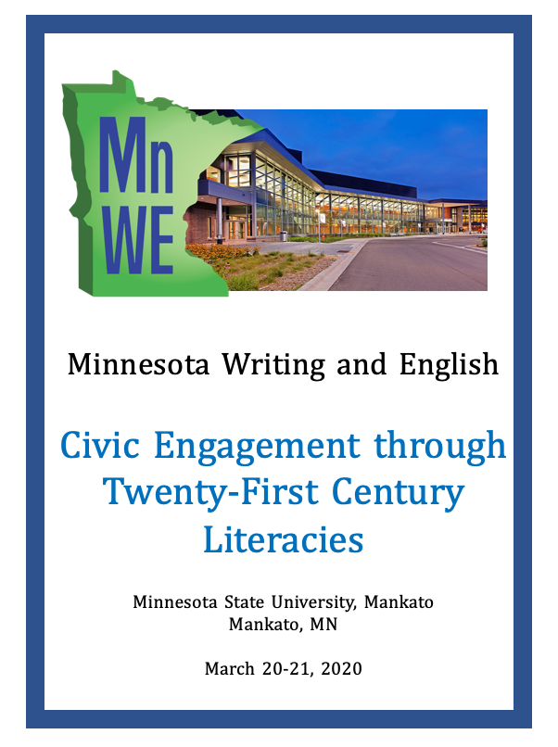

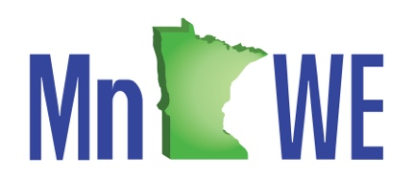

MnWE is “Minnesota Writing and English,” a consortium of Upper Midwest college and university writing and English faculty and staff centered in Minnesota. Our annual two-day conference each spring attracts up to 200 attendees, and we send the bi-monthly “MnWE News” by email to about 3000 members in Minnesota and surrounding states and one province. Ours is an entirely volunteer-run organization, and we always welcome new members. If you would like to join the planning, contact Richard Jewell or join us at our meeting at the end of the conference.

MnWE Committee

Richard Jewell, General Coordinator
Inver Hills College
richard@jewell.net

Larry Sklaney, Conference Coordinator
Century College
larry.sklaney@century.edu

Danielle Hinrichs, Program Coordinator
Metropolitan State University
danielle.hinrichs@metrostate.edu

Ellen Zamarripa, Volunteer Coordinator
Walden University
ellen.zamarripa@mail.waldenu.edu

Kirsti Cole, Site Host Coordinator
Minnesota State University, Mankato, kirsti.cole@mnsu.edu

Heidi Burns, Registration Coordinator
Minnesota State University, Mankato
heidi.burns@mnsu.edu

Gordon Pueschner, Onsite Coordinator
Century College
gordon.pueschner@century.edu

Mark Brenden, Proposals Coordinator
University of Minnesota
brend053@umn.edu

Edward Hahn, Web Coordinator
Inver Hills Community College
EHahn@inverhills.edu

Kerrie Patterson, Treasurer
Hennepin Technical College,
kerrie.patterson@hennepintech.edu

Jana Rieck, Communications Coordinator
Champlin Park Senior High School
JanaRieck.MnWE@gmail

Mary Taris, Tabling Coordinator
Strive Publishing
mary@strivepublishing.com

Alexander Champoux-Crowley
University of Minnesota
champ147@umn.edu

Mary Ellen Daniloff-Merrill
Southwest Minnesota State University
beadathlon_1@yahoo.com

Yanmei Jiang
Century College,
yanmei.jiang@century.edu

Darryl Johnson
Emeritus, Anoka Technical College
daugustj@gmail.com

Max G. Philbrook
Walden University
maxwell.philbrook@mail.walden.edu

Beata Pueschner
Anoka Ramsey Community College,
beata.pueschner@anokaramsey.edu

Donald Ross
University of Minnesota Twin Cities
rossj001@umn.edu

Linda Tetzlaff
Normandale Community College
linda.tetzlaff@normandale.edu

Minnesota State University Mankato Campus Maps

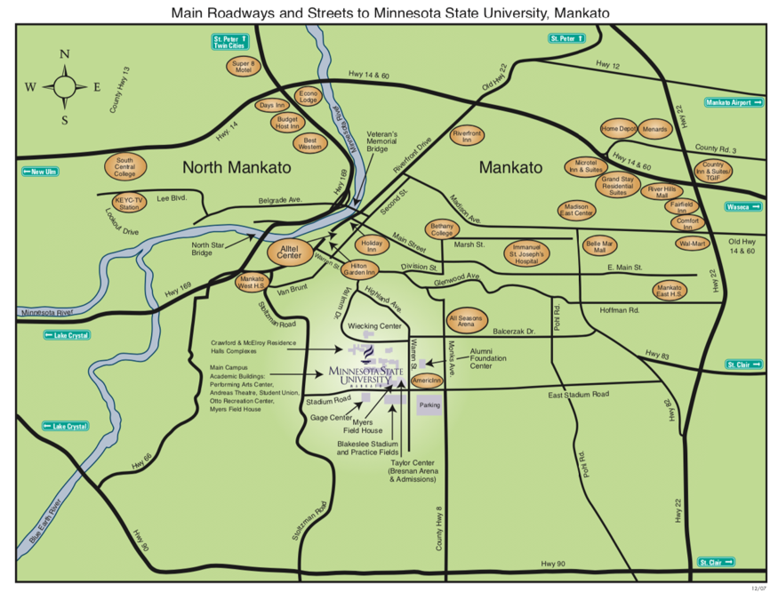
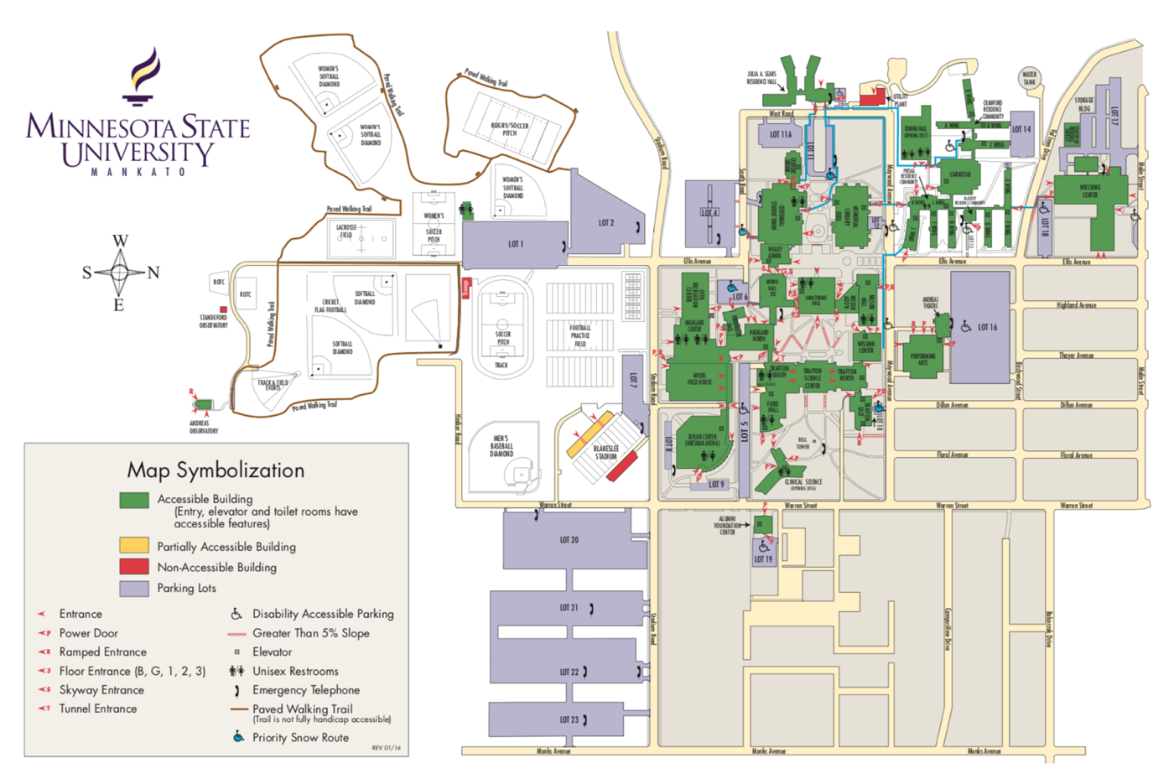

Parking Map

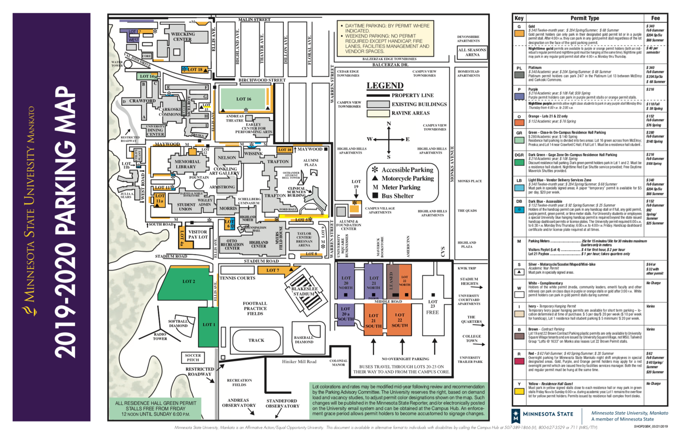

Centennial Student Union 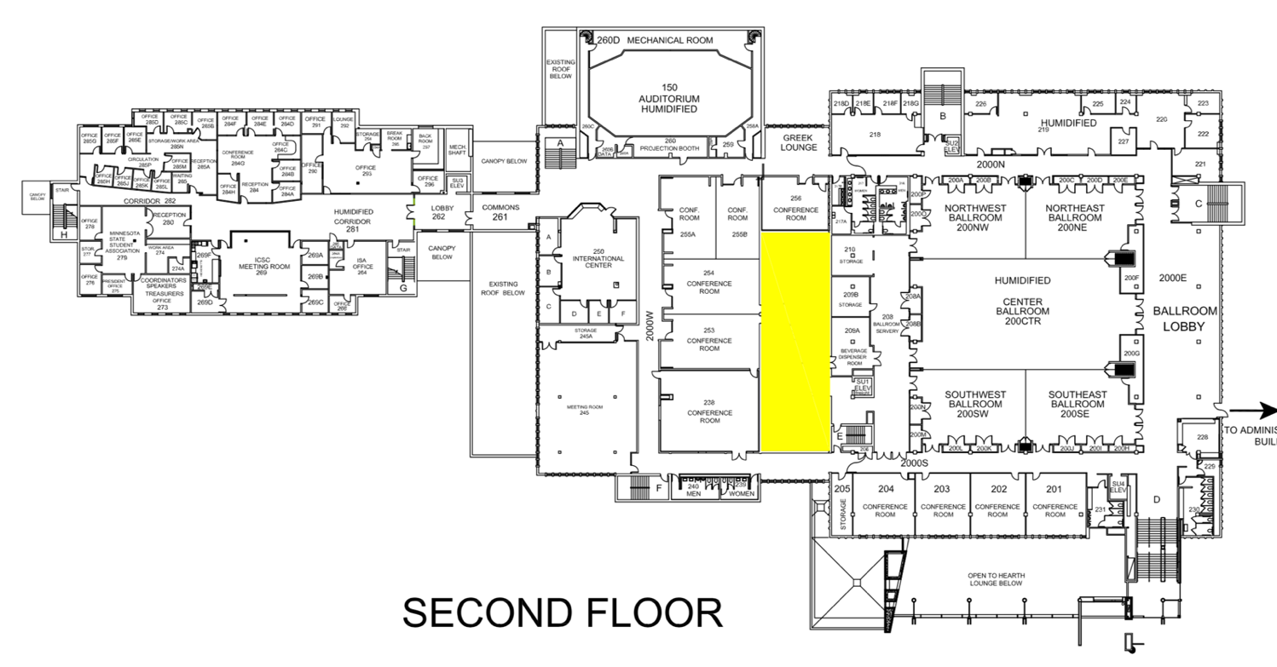

Morris Hall

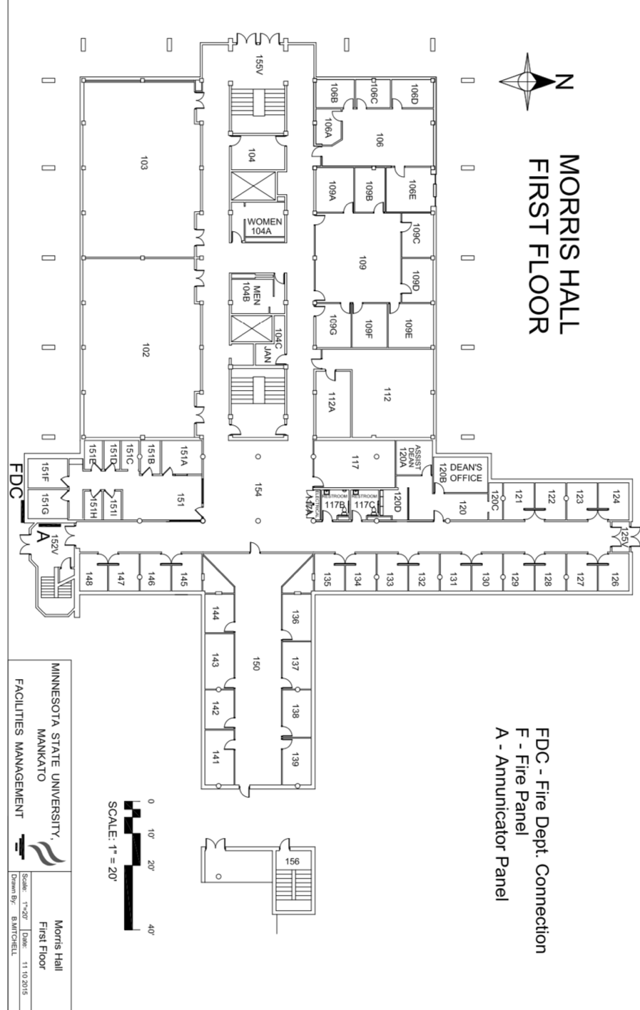

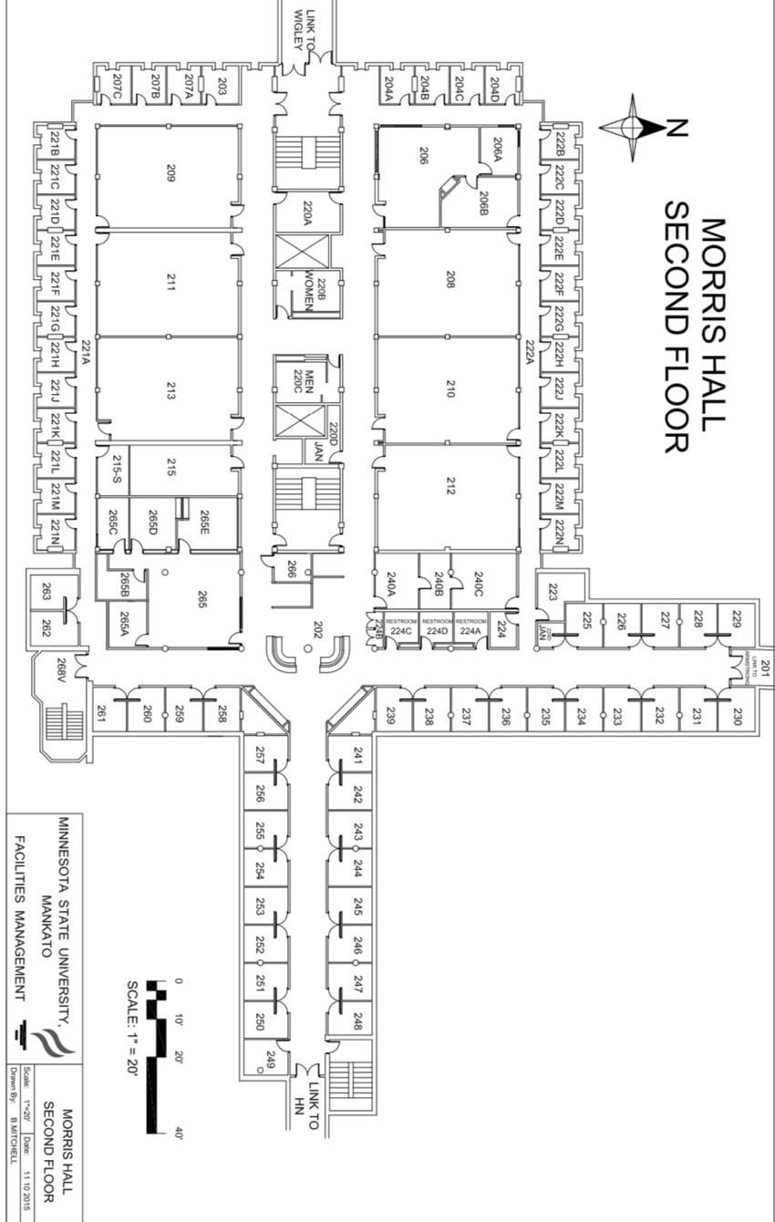

Mankato, Minnesota
Basics on Mankato:
Mankato and North Mankato are a metro area of 100,000 people with 25,000 students at Minnesota State-Mankato and four other nearby accredited colleges and universities. The city carries an outsized impact as the largest city in its multi-country area, serving as an educational, cultural, and political capital in the southern central-west part of Minnesota. There is so much to do in and around Mankato that you might want to consider stretching your visit to an extra night and day.
Visiting Mankato: The National Scenic Byway, and Sites about the Nationally Historic Dakota-U.S. War and Hanging:
The drive to and from Mankato can be a special tour in itself. You can take the Minnesota River Valley National Scenic Byway in two different directions, one part between the South Dakota border and southeast down the river, or another part southwest from the Twin Cities between Belle Plaine and Mankato). The drive highlights a river extremely important in the settlement of the Minnesota plains, and also of vital importance to the Dakota Indians. You can allow time for stopping points with close sights of the River, plaques, and interpretive centers, or you simply can follow the National Scenic Byway for its beautiful views.
An important visitor opportunity related to our conference theme is the nationally significant 1862 hanging of 38 Dakota Indian warriors, the largest U.S. mass execution. You can take a self-guided tour at thirty-three sites, each with interpretation.
Prefacing the execution, ordered by President Lincoln, the five-week Dakota-U.S. War of 1862 saw an early major defeat of U.S. militias by an Indian army, leading to other battles and defeat of the warriors. On record, over 400 white settlers and soldiers were killed, but the toll likely was two or three times higher when Indian deaths are included, and thousands more Indians left their lands before and after because of land theft, starvation, and later mass removal encouraged by settler and army fear and revenge.
Other Sites to See and Experience in Mankato:
Mankato visitors enjoy art, literature (specifically, poetry and Betsy-Tacy), and museums. Regarding art, the national ranking site Thrillist gave a “14 Coolest Urban Spaces in America” award to Mankato for its downtown CityArt Walking Sculpture Tour. You also can tour the “Mankato Poetry Walk and Ride” and “WordWalk” on sidewalks and paths, and the “CityArt On the Go” with traffic signal boxes turned into murals. You also can visit several established art galleries, as well as museums such as the Blue Earth Historical Society, the Betsy-Tacy Houses (“bringing classic books by Maud Har Lovelace alive”), and, for your kids, the Children’s Museum of Southern Minnesota.
Other features of Mankato include the large and popular River Hills Mall, dozens of restaurants of many ethnic types, four wineries, and a lively downtown. If you are an outdoor enthusiast, plenty of trails and riverways beckon for hiking, biking, rowing, and canoeing/kayaking, along with shops for gear and outfitting. Mankato’s Blue Earth County also boasts more river shore than any other Minnesota County, along with plenty of public beaches and parks with dining shelters, children’s playground equipment, and a petting zoo.
Web Links:
Minnesota River Valley National Scenic Byway and map: www.mnrivervalley.com
1862 Dakota War tour: U.S.-Dakota-Conflict-of-1862-Self-Guided-Tour-brochure.pdf

---
Travel Guides, online viewing/ordering: www.visitgreatermankato.com/travel-guides
General Visitor Site: https://www.visitgreatermankato.com
Direct info/guidebook requests: visitors@greatermankato.com, ph. 1-800-657-4733
Schedule at a Glance

Friday, March 20

8:00-8:45: Coffee Hour
8:00-3:00: Registration
8:45-9:00: MnWE Welcome
9:00-10:10: Plenary Session
10:20-11:35: Breakout Session A
11:40-1:15: Lunch and Keynote
1:25-2:40: Breakout Session B
2:50-4:05: Breakout Session C
4:30-6:30: Happy Hour and Dinner (Everyone welcome)

Saturday, March 21

8:00-8:45: Coffee Hour
8:00-3:00: Registration
8:45-9:00: MnWE Welcome

9:00-10:10: Plenary Session

10:20-11:35: Breakout Session D

11:40-1:15: Lunch and Keynote

1:25-2:40: Breakout Session E

2:50-4:05: Breakout Session F

4:15-5:15: MnWE Committee Meeting (Everyone welcome)

5:30-7:00: Dinner (Everyone welcome)

Registration: Friday, March 20, Beginning at 8:00 a.m.
Join MnWE attendees for Registration and Coffee from 8:00-8:45.

Registration continues until 3:00 p.m.

Plenary: Friday, March 20, 8:45-10:10 a.m.
Welcome and Announcements | Larry Sklaney, MnWE Conference Coordinator | CSU  Ballroom
Plenary | "Connecting Classrooms and Communities"  David Beard  Associate Professor of Rhetoric, Scientific, and Technical Communication  University of Minnesota-Duluth  Jasmine Kar Tang  Co-Director of the Center for Writing  Assistant Director of the Minnesota Writing Project  University of Minnesota, Twin Cities  Kevin Lindsey  CEO of the Minnesota Humanities Center  Mary Taris  Publisher and CEO of Strive Publishing | CSU  Ballroom

Breakout Session A: Friday, March 20, 10:20-11:35 a.m.
Individual Presentations | “‘I Can’t Tell if They’re Lying to Me’: Helping Students Navigate Media Bias”  Victoria Holtz Wodzak, Viterbo University  “Learning to Question: Teaching Skepticism as a Critical Tool for Evaluating Information in the Public Sphere”  Austin Harrington, Iowa State University | CSU 201
Individual Presentations | “Intellectual Activism in the Composition Classroom”  Heidi Newbauer, Minnesota State University Mankato  “Teaching Composition through the Rhetoric and Spectacle of Presidential Politics”  Jennifer Forsthoefel, Augsburg University | CSU 202
Individual Presentations | “‘Why My Students Blog: Finding Self and Community in the Online World”  Bonnie Robinson, Rochester Community and Technical College  “Building Accessible Digital Texts and Multiliteracies”  Rachel Tofteland-Trampe, Hamline University | CSU 203
Individual Presentations | “Comparing in the Midst of Contrasting: Shifting Strategies and Literacies for the ELL Classroom”  Matt Muilenburg, University of Dubuque  “Improving TESOL With Former Students’ Strategies on How to Take Action”  Qabzib Hang, University of Minnesota Twin Cities | CSU 204
Workshop | Become a More Resilient Educator: Five Simple Steps  Pam Whitfield, Rochester Community and Technical College | CSU 253
Workshop | “Education by Poetry: Use and Practice”  Daniel Bernstrom, Minnesota West Community and Technical College & MSC Southeast | CSU 254

Keynote: Friday, March 20, 11:40 a.m.-1:15 p.m.
Lunch and Keynote | - Welcome from Richard Jewell, MnWE General Coordinator | CSU  Ballroom

Beth Godbee
“Breaking Civil Discourse:
Cultivating Productive and Receptive Literacies for Responsible (Response-Able) Engagement”
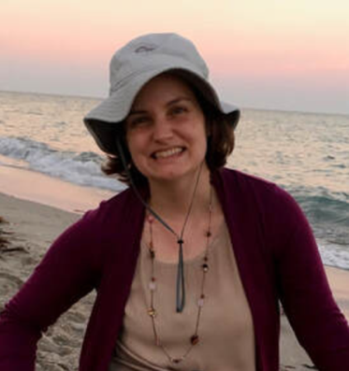

Our keynote speaker is an educator, writer, entrepreneur, and former professor whose research addresses matters of social, racial, and environmental justice; power, agency, and rights; and relational communication. She brings experiences as a K-12 teacher; community literacy instructor; writing center consultant; writing program administrator; facilitator of community-based learning; and researcher in composition, rhetoric, and literacy studies.
This interactive presentation engages the dialectic of critique against and critique for: both problematizing “civic engagement” and pointing toward literacy education aligned with justice (social, racial, and environmental justice). Together, we’ll consider where investment in civic engagement comes from, particularly at a time when civic participation, civil discourse, and related constructs of citizenship and national borders provide justifications for excluding and dehumanizing people.
How, then, do we interrupt these injustices? What learning and unlearning is needed now—not only in the context of “21st century literacies” but also within white supremacy, heteropatriarchy, settler colonialism, and interlocking oppressions? In total, this presentation invites us to consider what it means to shift from civic engagement to collective responsibilities. Doing so involves asking to whom we are responsible, when, where, how, and why. As educators, how are we cultivating the response-abilities for interrupting injustice and striving toward more just relations?

You can find Beth Godbee online at Heart-Head-Hands.com, a blog with storytelling, resources, and e-courses focused on feeling, thinking, and doing—that is, everyday living—for justice.

Breakout Session B: Friday, March 20, 1:25-2:40 p.m.
Individual Presentations | “Civic Engagement in Cather Country: Literacy and Lifelong Learning”  Susan Maher, University of Minnesota Duluth  “Double Jeopardy or Double Win—Conflicts and Politics behind The Woman Warrior”  Zhen Tu, Yale University | CSU 201
Individual Presentations | “Critical Reading of Memorialization”  Elizabethada Wright, University of Minnesota Duluth  “Family History Literacy for Civic Engagement”  Katherine Challis, Iowa State University | CSU 202
Individual Presentations | “Spin Doctors”  Larry Sklaney, Century College  “Asking for Change: Civic Engagement Essay”  Lisa Heise, Western Technical College | CSU 203
Panel | “Educators’ Responses to Othering in Digital Space””  Chloe Clark, Iowa State University  Philippe Meister, Iowa State University  Erin Schmiel, Iowa State University | CSU 204
Panel | “Writing Instruction and Civic Engagement: Breaking Boundaries”  Patrick Bruch, University of Minnesota Twin Cities  Nicole Ciulla, University of Minnesota Twin Cities  Thomas Reynolds, University of Minnesota Twin Cities | CSU 253
Panel | “Transformational Teaching: Teaching Beyond the Curriculum”  Scri Acmar, International School  Waihon Liew, Sejong Academy | CSU 254
Creative Reading | Serious Spoken Word, Some of it Southern  Pam Whitfield, Rochester Community and Technical College | CSU 255

Breakout Session C: Friday, March 20, 2:50-4:05 p.m.
Individual Presentations | “‘Is it good?’: Using That Common Student Question as a Foundation for Supporting the Development of Students’ Critical Literacies”  Alyssa Adkins, Saint Paul College  “Put On Your Own Oxygen Mask First: Preparing to be an Effective Instructor for Teaching Civic Engagement in the 21st Century”  Heidi Burns, Minnesota State University Mankato | CSU 201
Individual Presentations | “Culturally Relevant Pedagogy and a Writing Unit about Hmong History”  Pam Solberg, Western Technical College  “Research Writing in the Digital Age: Integrating Writing and Information Literacy”  Michelle Filkins, Metropolitan State University  Danielle Hinrichs, Metropolitan State University | CSU 202
Individual Presentations | “Climate Change Theme in a Business Writing Course”  Donald Ross, University of Minnesota Twin Cities  “The Writing Pedagogy: Expositions from Conceptualization, Methodology and Findings”  Kingsley Chigbu, University of St. Thomas | CSU 203
Individual Presentations | “Power and Precision: Using Figurative Language”  Russ Markert, North Hennepin Community College  “Combating the Decline: Teaching Survey Courses in the 21st Century”  Ethan Voss, University of Minnesota Twin Cities | CSU 204
Individual Presentations | “Networking Civic Engagement: Actor-Network Theory and the Cultivation of Sustained, Transformative Community Writing Relationships”  Naomi Clark, Loras College  “Civic Engagement through Archival Pedagogies”  Benjamin Harley, Northern State University | CSU 253
Workshop | “Accuplacer and Next-Generation Accuplacer Discussion”  Mary Ellen Daniloff-Merrill, Southwest Minnesota State University | CSU 254

Dinner: Friday, March 20, 4:30-6:30 p.m.
MnWE Dinner  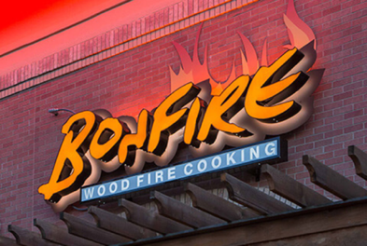 | Happy Hour and Dinner  Axel’s Bonfire Grill  1910 Premier Drive  Mankato, MN 56001 | 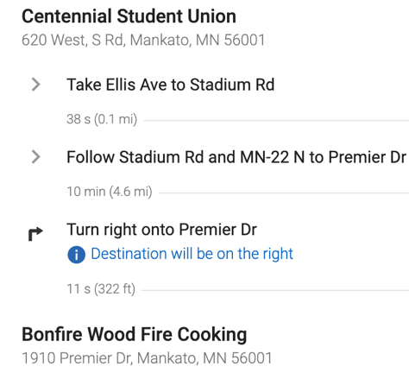

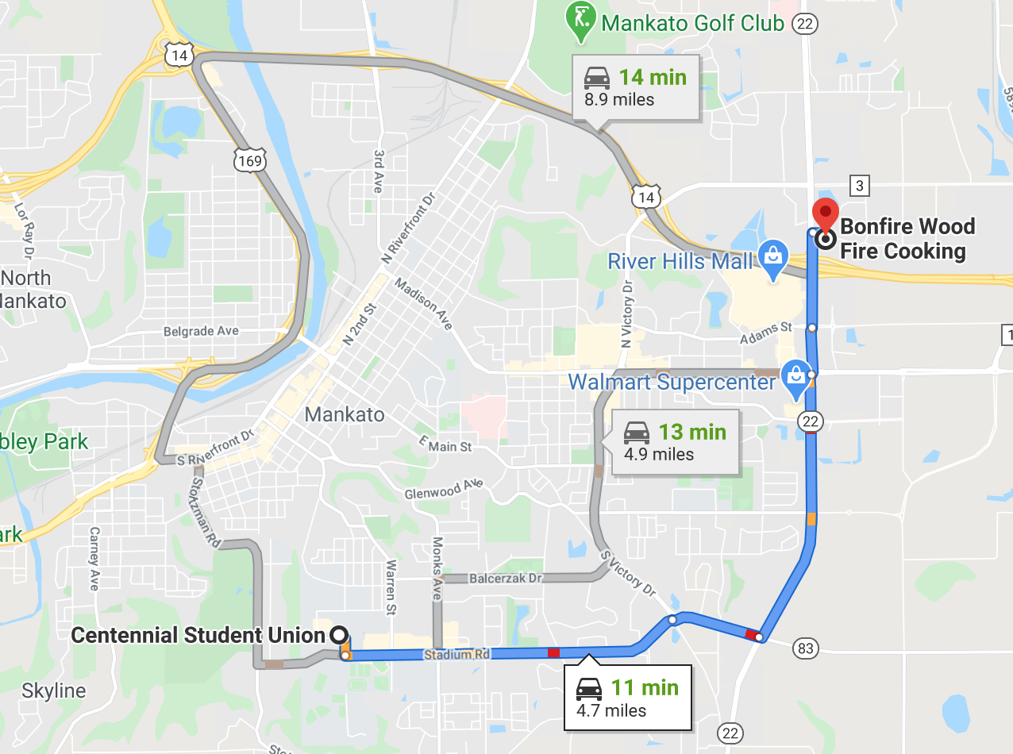

Registration: Saturday, March 21, Beginning at 8:00 a.m.
Join MnWE attendees for Registration and Coffee from 8:00-8:45.

Registration continues until 3:00 p.m.

Plenary: Saturday, March 21, 8:45-10:10 a.m.
Welcome and Announcements | Larry Sklaney, MnWE Conference Coordinator | CSU 253/4/5
Plenary | "Classroom Strategies for Engaging in Civic Literacy "  Kelly Moreland  Assistant Professor of Rhetoric and Composition  Minnesota State University, Mankato  Paolo Infante  Assistant Professor of TESOL  Minnesota State University, Mankato  Abigail Bakke  Assistant Professor of Technical Communication  Minnesota State University, Mankato  Jenny Turner  Instructional Services Librarian  Minnesota State University, Mankato | CSU 253/4/5

Breakout Session D: Saturday, March 21, 10:20-11:35 a.m.
Individual Presentations | “Reviving Rhetoric to Address Truth Decay”  Lynn Brice, University of Minnesota Duluth  “The Democratic (Rhetorical) Paradox: Civic Engagement and Access Rhetorics of Literacy”  Alexander Champoux-Crowley, University of Minnesota Twin Cities | CSU 245
Panel | “Energizing Political Engagement in New Constituencies through Digital Literacy”  Joyce Tang Boyland, Alverno College | Morris Hall 102
Panel | “Reimagining ‘21st-Century Literacies’: Practical and Theoretical Approaches to Multimodality in the FYW and Tech Comm classrooms”  Mark Brenden, University of Minnesota Twin Cities  Jacqueline James, University of Minnesota Twin Cities  Jessa Wood, University of Minnesota Twin Cities | Morris Hall 103
Panel | “The Politics and Dynamics of Storytelling”  Yanmei Jiang, English & Gender Studies faculty at Century College  Sophie Liu-Othmer, Chinese School Teacher, Choir Member,  Storytelling Champion, Database Administration  at US Bank  Gregory Pickett, Educator and Professional Storyteller  Mary Taris, Founder and CEO of Strive Publishing | Morris Hall 210
Workshop | “Developing Receptive Literacies, Civic Engagement, and 21st Century Skills Using Visual Thinking Strategies”  Kay Cutler, South Dakota State University  Doriane Paso, South Dakota State University  Lynn Verschoor, South Dakota State University | Morris Hall 211
Interactive Workshop | “Contemplative Practices for Shaking up and Shaking off “the Civic”  Beth Godbee  Jasmine Kar Tang, University of Minnesota Twin Cities  * This participatory workshop uses body-based contemplative activities to feel-think-do beyond the conference theme of civic engagement | Morris Hall 213

Keynote: Saturday, March 21, 11:40 a.m.-1:15 p.m.
Lunch and Keynote | - Welcome from Richard Jewell, MnWE General Coordinator | CSU 253/4/5

Ed Bok Lee
“Yet Another Other:
Migration, the Environment, and Poetry”

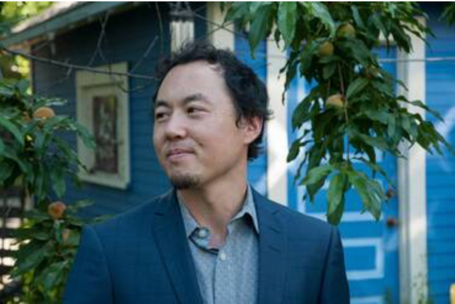

How can different perspectives and different bodies—otherness—become not a barrier, but a catalyst toward strengthening relationships between all people, societies, and living species throughout time? Award-winning poet and author Ed Bok Lee will present on why and how the “radically obvious” is now more important than ever toward evolving meaningful, productive civic engagement through the lenses of poetry, literature, and science. Presentation and Q and A.

Ed Bok Lee is the author of three books of poetry, most recently Mitochondrial Night (Coffee House Press, March 2019). The son of North and South Korean emigrants—his mother originally a refugee from what is now North Korea; his father was raised during the Japanese colonial period and Korean War in what is now South Korea, Lee grew up in South Korea, North Dakota, and Minnesota, and was educated there and later on both U.S. coasts, Russia, South Korea, and Kazakhstan. Honors include the American Book Award, Minnesota Book Award, Asian American Literary Award (Members’ Choice), and a PEN/Open Book Award. He is currently an Associate Professor in Fine Arts at Metropolitan State University, and for two decades has taught in programs for youth, communities of color, and the incarcerated. For information, visit www.edboklee.com

Breakout Session E: Saturday, March 21, 1:25-2:40 p.m.
Individual Presentations | “Making a Difference Online”  Mikayla Davis, University of Minnesota Twin Cities  “The Spotify Textbook: Using Podcasts as a Multimodal Text in a First-Year Writing Course”  Emily Gresbrink, University of Minnesota Twin Cities | CSU 245
Individual Presentations | “Civic Engagement and Science Fiction & Fantasy”  Jennifer Jodell, University of Minnesota Twin Cities  “Hybrid Texts and Social Thought”  Andrew David King, University of Iowa | Morris Hall 102
Individual Presentations | “Shaming & Digital Citizenship”  Dawn Armfield, Minnesota State University Mankato  “Wading through the Web of Differences to Build Bridges: A High School Junior’s Perspective and Experience”  Timothy Tu, Eagan High School | Morris Hall 103
Panel | “Teaching with Joy: Facilitating Community and Relationships”  Jill Caldwell, Century College  Julie Daniels, Century College  Dana LeMay, Century College | Morris Hall 210
Panel | “Addressing LGBTQ Content in the Classroom: Presentation, Reception, Transition”  Chad Kuehn, St. Cloud State University  Ulysses Texx, St. Cloud State University  Alan Toussaint, St. Cloud State University | Morris Hall 211
Panel | “Facilitating Rhetorical Research & Civic Engagement: WID/WEC in an Anthropology Capstone  Erin Crowley-Champoux, University of Minnesota Twin Cities  Alexander Champoux-Crowley, University of Minnesota Twin Cities | Morris Hall 213

Breakout Session F: Saturday, March 21, 2:50-4:05 p.m.
Individual Presentations | “Word Up! Rhetoric and African American Theory in 2020”  Alan Toussaint, St. Cloud State University  “Writing against American Indian Epistemicide: (Re)Integrating Indigenous Language into Rhetorical Theory”  Rachel Presley, University of Minnesota Twin Cities | CSU 245
Individual Presentations | “Jon Stewart, the Weatherman, Who Thinks Global Warming is Fake: Notes Towards Teaching Power Literacy”  Ulysses Texx, St. Cloud State University  “Teaching Argumentation as a Habit of Literacy”  Lianna Farber, University of Minnesota Twin Cities | Morris Hall 102
Individual Presentations | “Dismantling In-Group Identification: Lessons from the Nacirema about Generous Interpretations of Civil Discourse”  Mackenzie Krzmarzick, Anoka Ramsey Community College  “Discussion threads: An Opportunity to Build Civil Discourse”  Debbi McCuin, Mount Marty College | Morris Hall 103
Roundtable | “Transform Lives: Learn Current Events through Literature and Writing Courses”  Candice Camp, Century College Student  Yanmei Jiang, Century College Faculty  Sarah Larson, University of Minnesota Student  Davis Leaf, Century College Student | Morris Hall 210

MnWE Meeting: Saturday, March 21, 4:15-5:15 p.m.
MnWE Meeting  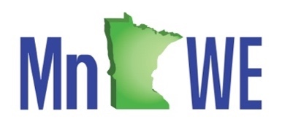 | MnWE Committee Meeting  New members, guests, and observers are welcome. | CSU 253/4/5

Dinner: Saturday, March 21, 5:30-7:00 p.m.
MnWE Dinner | Dinner  Grizzly’s Woodfire Grill  1700 Madison Avenue  Mankato, MN 56001  All are welcome. Sign up at the registration desk. | 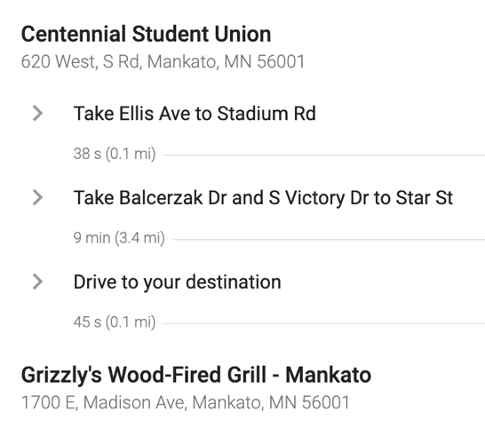

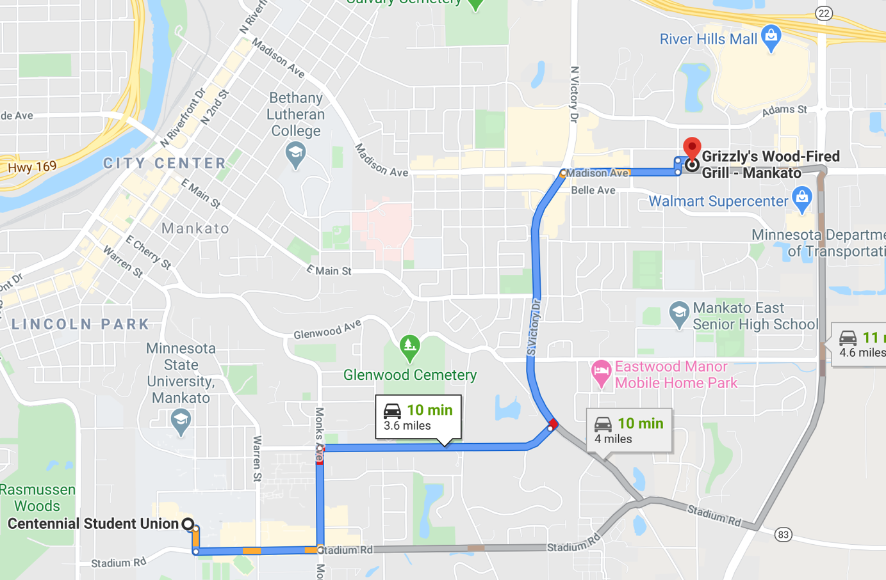
Join us for next year’s MnWE Conference!

March 26-27, 2021
The Minnesota Humanities Center
Phalen Regional Park, 987 Ivy Ave. East, St. Paul
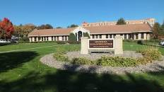 | 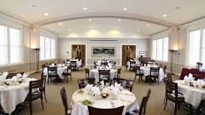
 | 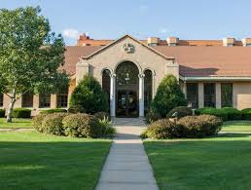
Join us for a great MnWE Conference next year on the beautiful shores of Lake Phalen in near-north St. Paul near I-35E and I-94.

2021 Friday Keynote by  Kevin Lindsey, CEO  Minnesota Humanities Center | 