Minnesota Writing and English Conference, 2021

Reinvent, Reinvest, Reinvigorate: Teaching after 2020
SCHEDULE OF EVENTS
Thursday, March 25

11:30 am-12:00 pm
MnWE Welcome

Larry Sklaney, Conference Coordinator; Richard Jewell, General Coordinator

Teaching During the Pandemic: Storytelling Performance by Greg Pickett

Lake Superior Room

12:00-1:15 pm
Plenary: Reinventing Composition Pedagogy after 2020
April Gibson, Malcolm X College
Jasmine Kar Tang, University of Minnesota Twin Cities
Rebecca Weaver, Georgia State—Perimeter College

Lake Superior Room

1:30-2:45 pm

Breakout Session A

See next page for session details.

3:00-4:15 pm

Breakout Session B

See next page for session details.

4:15-5:15 pm

Happy Hour & Literature Slam-A-Thon

Lake Superior Room
For questions or technology help, please call Gordy Pueschner at 651-686-4468.

BREAKOUT SESSION A

Thursday, March 25, 1:30-2:45 pm

- Open Resources, Ungrading, and Emancipatory Grading Strategies

Edward Hahn, North Hennepin Community College

Erin Kunz, Mayville State University

Sybil Priebe, North Dakota State College of Science

Lake Superior Room
- Inclusive Pedagogy for Multilingual Learners
Cheryl Caesar, Michigan State University
Joyce Meier, Michigan State University
Laura Funke, Inver Hills Community College
Lake Phalen Room
Rhetorical Approaches to Writing Instruction
Mikayla Davis, University of Minnesota Twin Cities
Emily Gresbrink, University of Minnesota Twin Cities
Russ Markert, Century College
Laura McCartan, Metropolitan State University
Carlos Toledo, Iowa State University

Lake Nokomis Room

Writing Center Theory, Research, and Practice
Lori Baker, Southwest Minnesota State University
Helen Friesen, University of Winnipeg
Kerrie Patterson, Hennepin Technical College
Beth Timmerman, Century College

Lake of the Woods Room

Community Storytelling

Yanmei Jiang, Century College

Greg Pickett, Harvest Best Academy

Sophie Liu-Othmer, Community Organizer

Teresa Callies, Century College
Lake Como Room

BREAKOUT SESSION B

Thursday, March 25, 3:00-4:15 pm

- Literature Pedagogy

Lianna Farber, University of Minnesota Twin Cities

Beth Boyens, Augustana University

Diana Cameron, North Iowa Area Community College

Lake Superior Room

- ELLoquently High School Tutors: Learning and Teaching over Zoom
Zhen Tu, Yale University (Eagan, MN)
Veronica Sikorski, Central High School (St. Paul, Minnesota)
Diana Gateno, Balboa Academy (Panama City, Panama)
Brian Wang, Homeschooled (Ontario, Canada)
Rita Li, Math and Science Academy (Woodbury, Minnesota)
Lake Phalen Room
Moving Writing Instruction Online: Composition 2020
Brandon Chitwood, Saint Paul College
Carla-Elaine Johnson, Saint Paul College
Adrienne Lamberti, University of Northern Iowa
Tamar Neumann, University of Nebraska Omaha

Katie O'Leary, South Dakota State University

Lake Nokomis Room

What Works Online: Effective Collaboration for Research and Writing Support

Luke Morgan, Metropolitan State University (Tutor Coordinator)

Alec Sonsteby, Metropolitan State University (Librarian)

Tracy Van der Leeuw, Metropolitan State University (Professional Tutor)

Dawn Wing, Metropolitan State University (Librarian)
Lake of the Woods Room
- Systems Thinking for Education and Community Development

Bugondo Blaise Ntibonera, Case Manager (Lutheran Social Services of Minnesota)

Waihon Liew, Teacher (Sejong Academy) and Community Mentor

Yanmei Jiang, Instructor (Century College)
Lake Como Room

4:15-5:15 pm

Happy Hour & Literature Slam-A-Thon

Lake Superior Room

We invite everyone to our Happy Hour and Literature Slam-A-Thon event on Thursday, March 25 from 4:15 because where else would you want to be during pandemic lockdown? Email larry.sklaney@century.edu if you’d like to get on the list to do a brief reading, either something you have written or something someone else has written that you would like to share. Bonus points for reading-appropriate hat or ZOOM filter. Since we’re on ZOOM, juggling flaming bowling pins etc. could also work as your contribution to the entertainment!

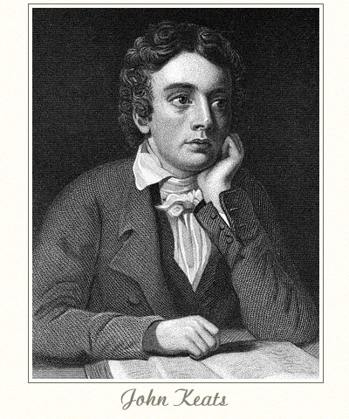 | 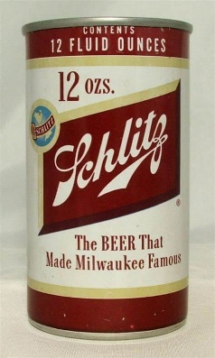

What mad pursuit? What struggle to escape?

What pipes and timbrels? What wild ecstasy?

What time is Happy Hour?

Minnesota Writing and English Conference, 2021
SCHEDULE OF EVENTS
Friday, March 26

10:00-10:30 am
MnWE Welcome

Larry Sklaney, Conference Coordinator; Richard Jewell, General Coordinator

Lake Superior Room

10:30-11:45 pm

Breakout Session C

See next page for session details.

12:00-1:30 pm
Plenary: Reinvigorating Community-Engaged Learning
Welcome from Kevin Lindsey, Minnesota Humanities Center
Myrl Beam, Macalester College
David Beard, University of Minnesota Duluth
Nicole (Niki) Ciulla, Saint Mary’s University of Minnesota

Lake Superior Room

1:45-3:00 pm

Breakout Session D

See next page for session details.

3:00-3:20 pm

MnWE Closure

Lake Superior Room

3:30-4:30 pm

MnWE Committee Meeting (Everyone Welcome)

Lake Superior Room

BREAKOUT SESSION C

Friday, March 26, 10:30-11:45 pm

- Pandemic Pedagogy Beyond Classroom Walls
Caroline Ledeboer, University of Northern Iowa
Maimuna Farazi, University of Northern Iowa
Ryan Eichberger, St. Olaf College
Lisa Whalen, North Hennepin Community College
Brian Baumgart, North Hennepin Community College

Lake Superior Room

- Antiracism and Social Justice

Jacqueline Herbers, Viterbo University

Donald Ross, University of Minnesota Twin Cities

Katherine (Kassy) Skoretz, Anoka Ramsey Community College

Geethu M. Jose, SCMS Cochin School of Business, India

Bde Maka Ska Room

3. Active Learning in an Inactive Place: Engaging Virtual Composition Students

Charmayne Mulligan, Davenport University

Melissa Lewis, Davenport University

Gina Ostien, Davenport University

Lake Nokomis Room

- Creative Writing Pedagogy and Practice
Kai Harris, Western Michigan University
Andrew David King, University of California, Davis
Said Farah, University of Minnesota

Lake of the Woods Room

- Colleging During the Pandemic: A Transnational Perspective

Yanmei Jiang, Century College (English)
Ryuto Hashimoto, Century College (Global Studies)
Rundong (David) Wu, University of Texas (Economics)
Michał Skubisz, Heidelberg University, Germany (Japanese Studies)
Yuxuan Zhou, Central University of Finance and Economics, China (Marketing)
Zhen Tu, Yale University (History and Piano)

Lake Como Room

12:00-1:30 pm
Plenary: Reinvigorating Community-Engaged Learning
Welcome from Kevin Lindsey, Minnesota Humanities Center
Myrl Beam, Macalester College
David Beard, University of Minnesota, Duluth
Nicole (Niki) Ciulla, Saint Mary’s University of MN

Lake Superior Room

BREAKOUT SESSION D

Friday, March 26, 1:45-3:00 pm

- Receptive Literacies and Civic Engagement through Visual Thinking Strategies

Doriane Paso, South Dakota State University

Kay M. Cutler, South Dakota State University

Mary Moeller, South Dakota State University

Lake Superior Room

- Teaching English and Making Cultural Connections on Zoom
Zhen Tu, Yale University
Timmy Tu, Eagan High School
Arush Iyer, Eagan High School
Linda Clemens, Century College
Bde Maka Ska Room
- Engaging Students in Online Writing Courses
Cody Bursch, University of Minnesota
Shaya Kraut, St. Cloud State University
Joseph Moser, University of St. Thomas
Linda O'Malley, Metropolitan State University
Ethan Voss, University of Minnesota

Lake Nokomis Room
- Teaching with Diverse Texts

Don Dingledine, University of Wisconsin Oshkosh

Whitney Jacobson, University of Minnesota Duluth

Rekhet Si-Asar, Minnesota Black Publishing Arts Collaborative

Mary Taris, Minnesota Black Publishing Arts Collaborative

Lake of the Woods Room

- Lives from the Margins: Inching through the Boundaries of Academic Literacy

Yanmei Jiang, Century College (English Faculty)
Jackie Reichter, Century College (Tutor Director)
Cheryl Yeboah-Heuwald, Century College (Nursing Student)
Edmund McClain, Century College (Law Enforcement Student)

Ryuto Hashimoto, Century College (Global Studies Student)
Lake Como Room

- Teaching on Shifting Ground: Pandemic Pedagogy

Patrick Bruch, University of Minnesota Twin Cities

Thomas Reynolds, University of Minnesota Twin Cities

Mark Brenden, University of Minnesota Twin Cities

Luke Shackelford, University of Minnesota Twin Cities

Lake of the Isles Room

3:00-3:20 pm

MnWE Closure

Lake Superior Room

3:30-4:30 pm

MnWE Committee Meeting (Everyone Welcome)

Lake Superior Room

Minnesota Writing and English Conference

April 7 and 8, 2022

Minnesota Humanities Center

Keynote Speaker

Kevin Lindsey, CEO MN Humanities Center
Kevin is a widely respected advocate and lawyer with a wealth of experience in public policy and education reform. A proven change-maker, Kevin’s career has focused on finding solutions to complex issues for institutions, both internally and externally. Kevin has a passion for inclusion for all, building a stronger democracy, and leveraging the power of personal stories. Kevin has held numerous governmental and nonprofit positions; such as board chair and interim executive director of Walker West Music Academy and most recently serving as the Commissioner of the Minnesota Department of Human Rights from 2011 to 2019. He was recently honored by his alma mater with the 2017 Iowa Law Review Distinguished Alumni Award and recognized as a “50 Over 50 disruptor honoree” by AARP Minnesota and Pollen 2018.

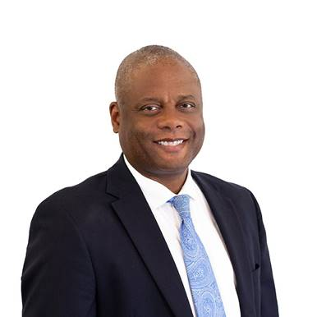
The Minnesota Humanities Center
Founded in 1971, the Minnesota Humanities Center (MHC) is a statewide nonprofit organization and full service event center located in Saint Paul, Minnesota. The Humanities Center offers a new way to think about our future, grounded in the humanities, and collaborates with organizations and individuals to develop programs that facilitate and frame conversations and strengthen connections. The Humanities Center works to bring into public life the authentic voices of all people, especially those that have been absent or marginalized. The Humanities Center is a resource for the state of Minnesota and is affiliated with the National Endowment for the Humanities.

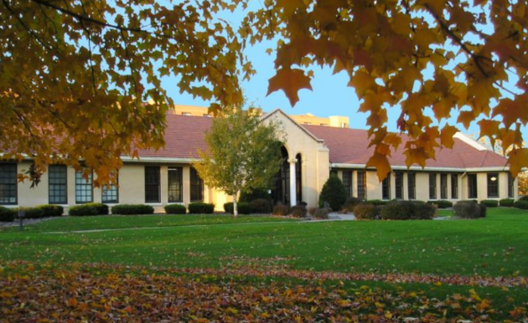

For questions or technology help, please call Gordy Pueschner at 651-686-4468.

