- Poetry by police and prisoners – what do they write about.

- How do cops “go bad” - - - how do others “stay good” - - two novels help us think about the question.

- What does the public think about law enforcement, and what shapes those perceptions.

- “If You Shoot My Dog, I Ma Kill Yo’ Cat: An Enquiry into the Principles of Hip-Hop Law” – what can rap tell us about law enforcement.

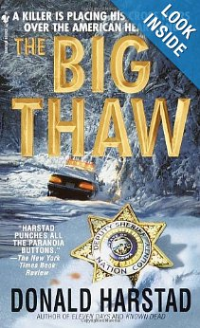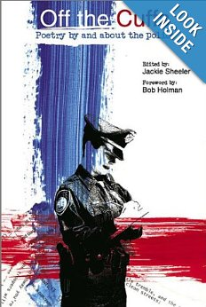

Law Enforcement in Contemporary Literature

Spring 2020 – Tues./Thurs. 11:00 a.m. - 12:10 p.m. (hybrid course – one credit hour online)

We look at fictional accounts, and poetry and drama (including radio and television shows and rap videos), that explore the public perception of law enforcement and those who make up the law enforcement community, and the perceptions of those who play the principal roles in the drama that is law enforcement – police officers and sheriffs/deputies, investigators, lawyers, judges, victims, the accused, the convicted, the imprisoned, the family members, the bystanders.

Questions? Contact Diana Cameron camerdia@niacc.edu

